

St Matthew’s Bloxam C of E Primary School
“Let Your Light Shine”

Anxiety and Stress Student Support Pack.

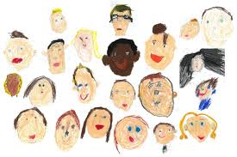

What is this pack?
This pack contains information and strategies to use at home or in school to deal with stress and anxiety. As a school we are here to help you and we are always here for you no matter what.
Mental health is something that we do not like to talk about and it can often not been seen by anyone other than the person dealing with it, but it should not be like that. You should be able to get support and help from people in school, but we know that sometimes you may need extra support from other agencies so we have included some of the links to these below.
The rest of the pack has been developed to support you with strategies that you can use at home during this difficult time, nobody expected us to be off school for so long or for a virus to take over our lives, but we will be back together soon and remember we are here to support you throughout.

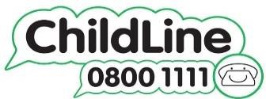

ChildLine is available to you if you have any concerns about:
- Bullying
- Abuse (physical, sexual, psychological, emotional, neglect)
- Your body and self esteem
- Your feelings
- Friendships
- Home life and families

Dealing with worries
Worries are a part of everyday life and often things will seem worse when you are alone or at night. This is because during the day and when you are in other people’s company your mind is kept busy. You might think about the things that are worrying you, but they come and go. At night your brain has time to think and overthink things that have happened and you are in your own company. You might begin to panic and things happen to your body, such as you start to sweat, your heart begins to beat faster and you may even struggle for a breath. This is normal and we all go through this from time to time, but it is good to have strategies to deal with this when it happens.

Here are some strategies that could help and a worry jar on the next page that you can use straight away.

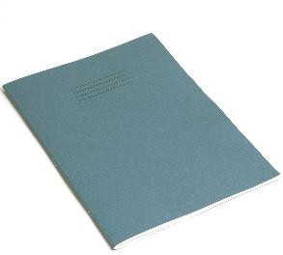
A worry book
This is a book that belongs to you and only you, you can write all of your worries in it as they come into your head. Getting them down on paper and looking at them can help as it allows them to leave your body and be something real rather than just in your head. If you want, you can invite someone you trust to read your worries at the end of the day, or whenever you want. This will give you a chance to talk about your worries and then get the advice of another person. You have to invite that person to read your book though as it belongs to you. A good idea would be to set some time aside each day, maybe even the same time to go through your worries.
- A worry monster
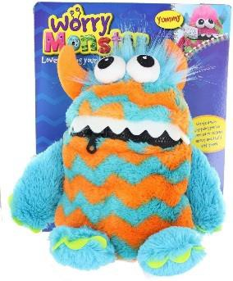
A worry monster is a soft toy that is very similar to the book above, the idea is that you write your worries on a piece of paper and then you put it inside the monster and zip up its mouth. This means that the monster has taken your worries from you and it now has them and you can see the monster taking your worries off you. You can buy the worry monsters with the zipped up mouths here https://www.amazon.co.uk/Worry-Monster-Plush-Soft- orange/dp/B010NDN2IU and on other websites. If you cannot buy a monster or to with a zip on its mouth, you could also just write your monster a note or tell it your worries. These are great as they do not judge you and all you are doing is offloading onto the monster.

You can use other sealed items such as jars or money boxes and then the worries are locked away.


A time capsule
This is very similar to the monster or jar above, but what you do is create a time capsule, this can be a container of any kind that you want. You write down all of your worries and put them inside the container and date them. You then seal the container so that nobody can get access to it, not even you.

When your worries are inside you can either have a hidden in your house, or even better, if you have a garden you can ask permission from your parents/carers to dig a hole and bury it, not too deep as you might want to add more worries when they come up. Then when everything is sorted, you can open it up and read what you were worried about and think about how small that worry actually was.
- Talk to someone

This is by far the best thing to do, but only if you feel comfortable with it and with someone that you trust. Opening up and speaking to someone allows you to get their views and support on what is happening. They may be able to offer you advice or get you some support from another professional. Bottling up your worries is not a good thing to do as they become overwhelming and can affect your mental and physical health.

A Worry Jar

This is a worry jar, if you are feeling stressed and worried about something then put it in the jar by writing it down. The top of the jar is sealed so that the worry cannot get out of it.
Once it is locked in the jar it is time to think about the positives and negative of the worry and there can be positives that come from a worry, just think really hard, write these down and use two different colours to write them down, choose your favourite colour for the positives and another colour for the negatives.
If you want, you can even share your worry with someone else so that the can help you, but you have to be comfortable to do this.


Our body’s reaction
Our bodies react in different ways to stress and sometimes we need to work out what is happening to us and how we can deal with it, different parts of our boy can be affected by stress.
The next two sheets will help you think about what is going on in your body and how to come up with ways to control how you are feeling.
On this sheet fill in any gaps and circle the statements that apply to you, green is okay and red means that you are not feeling as good as you could.

 | Brain | I am feeling really calm and in a good place. My thoughts are clear and I can think about good things that make me happy. | I am not feeling calm and I have lots of different thoughts in my head right now and I am worrying about things. I want to escape and get away from my thoughts
 | Our brain is where we
 | think about our worries
 | and anxieties. If we are
 | calm we can think clearly,
 | if we feel anxious our brain
 | overthinks everything
 | Heart  Our heart can tell us a lot about how we are feeling. Normal heart rate is 60/80 beats per minute. When we feel anxious our heart beats faster. | My heart is beating at a normal rate and rhythm. Measure your heart rate by finding and counting your pulse  Heart rate bpm | My heart is beating faster than normal and it feels really in my chest.  Measure your heart rate by finding and counting your pulse  Heart rate bpm
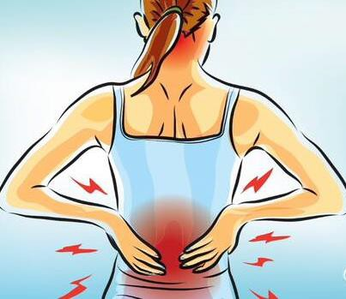 | Tension
 | We often feel stress and anxiety in our muscles and they might feel tight or like there is a ball in part of our body | My muscles do not feel any different and I feel okay | I feel like I have a tension in my muscles and a ball of worry in my body and it is  (where in your body?)
 | Hands and feet
 | When we are stressed or anxious we tend to move our hands and feet more. We can pick or bite our nails or tap our feet against the floor or something we are by. | I am in control of my body and I feel calm, my hands and feet are not moving and I do not feel the need to fidget. | My body feels restless and I  feel like I need to fidget with something, or bite or pick my nails or tap my feet against something. My legs and hands might even feel painful.

 | Voice
 | The way that we talk can change when we are stressed or anxious. We can either talk really quietly and not very much or very fast and a lot. | My voice is fine and I am talking normally.

I really don’t want to talk to anyone and feel like I can’t or I am talking really fast and talking about so much at once and some of it makes no sense.

Other things that your body may also feel if you are anxious or stressed are:

Sweat | Shaking | Feeling hot or cold | Emotions
You will sweat more when you are stressed or anxious | Your body will shake more when you are stress or anxious | Your body may feel hotter or colder if you are stressed of anxious | You may feel more emotional and cry if you are stressed or anxious

My body and my thoughts
On the outline of the body below, write down how your body feels and the changes that you have noticed. On the outside of the body write down all of the thoughts that you are having. This get you to think about how these thoughts are impacting upon your physical and mental health.


Mental Health Thermometer
I feel tired today and I cannot be bothered with anything or anyone.

I feel down and depressed. I feel agitated by things.
1
I do not feel stressed or anxious and things are going really well today.

I feel happy and I am in my good place

People are not annoying me today and I am enjoying their company.
2
I feel okay, some things are annoying me, but I can deal with them.

I feel like I can cope and get on with my day.

I feel like I could be in a good place if things carry on this way.
3
I feel slightly stressed and anxious

I feel like something is bothering me I feel agitated and want to fidget
I feel like the smallest thing might make me angry and even more stressed.
4
This is a tool that can help you think about how stressed, anxious or frustrated you feel. The aim is that you know how you are currently feeling, can describe this and then think of things that will help you calm down and feel better. We ideally want to be in the green zone as this is our happy place. Write down your strategies to take you down to the next level on the scale

Scale How I am feeling Strategies to support me
I feel really stressed and anxious I feel really angry and unhappy
I feel like I am going to explode

I feel like I may hurt someone or break something
5

Some suggested strategies
Below are some suggested strategies that you could use and put into whatever box you like to support you, remember this is personal and each strategy is personal to you and only you.
Give me some space
Do not ask me how I am feeling Let me listen to my music
Let me eat something
Get me something to take my mind off this
Do not challenge me
Get me to my trusted adult/member of staff
Give me some space Ask me questions
Give me something else to talk about
Let me draw something Get me to a safe space Get me my favourite toy
Do not speak too loud
Do not talk to me
Ask me how I am feeling Get me a drink
Do not make me do work Let me read
Get me my worry book Let me go and play sport
Let me play with my fidget toy

These are only suggestions, but you can think of your own strategies or things that will help you and put them into the boxes on the chart on the previous page. If you need any help with this, ask an adult.

Stress Bottle/Jar
This is a very simple stress reliever that you can make at home or in school. This jar is yours and you can design it in any way that you wish and that will help you. Below are instructions and the equipment that you will need to make this simple stress bottle/jar. This is something that you can use as a strategy above.
Equipment needed
An empty bottle with a lid Warm water
PVA Glue or Glitter Glue
Glitter if just using PVA glue
Craft stars, buttons, gems (optional)
Instructions
- Clean out the empty bottle and remember to keep the lid. Rinse it out so that no soap is left in it.
- Add you Glitter glue into the bottle or if you are using PVA and glitter, mix it up and then put it into the bottle.
- Add the warm water, but do not fill it right to the top.
- Put the lid on and give the bottle a shake.
- Let the mixture settle for a minute or two.
- Add any craft stars, buttons and gems into the bottle.
- Put the lid back on and give it another shake.
- It is complete, but you can decorate the outside of the bottle if you wish.

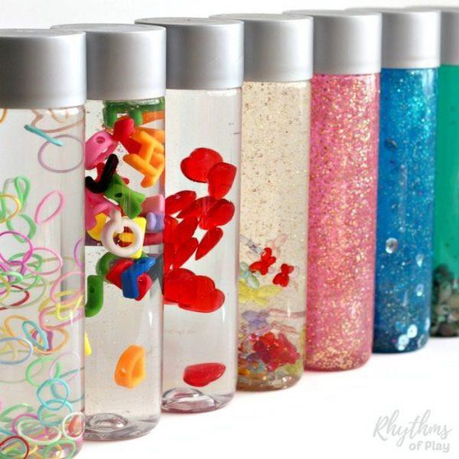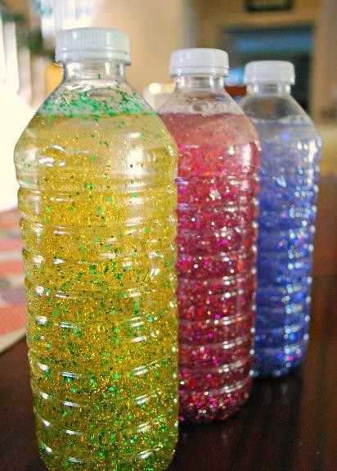
How to use
Every time you feel stressed or anxious or when you can feel it building up, grab your stress bottle/jar and give it a good shake to get all of your anxiety and tension out.
Place the bottle on a flat surface, sit down and watch the inside of the bottle begin to calm and settle down.
Use this as often as you like and for as long as you need.

Understanding our Brain
When we feel stressed our bodies react in two ways, this is often called fight of flight. These are the body’s natural defence mechanism and is something that our ancestors learnt a long time ago.

When we are feeling good our brain is working in perfect harmony, this means that all the part of our brain are working together. The pictures and descriptions below should help you to understand your brain a little bit more.
Our mid/lower brain is being hugged by the upper brain and so it is being protected and it is feeling safe. This part of the brain is often referred to as the ‘cave man’ part of our brain.
This part of our brain is responsible for our big emotions and when we lose control. Because it is being kept safe and communicating with the top part of our brain we feel calm.
Our upper brain is working to process all of the information that is coming in as it is able to communicate with the mid brain as they are connected. This part of the brain is used for reasoning, making judgements and being able to socialise.

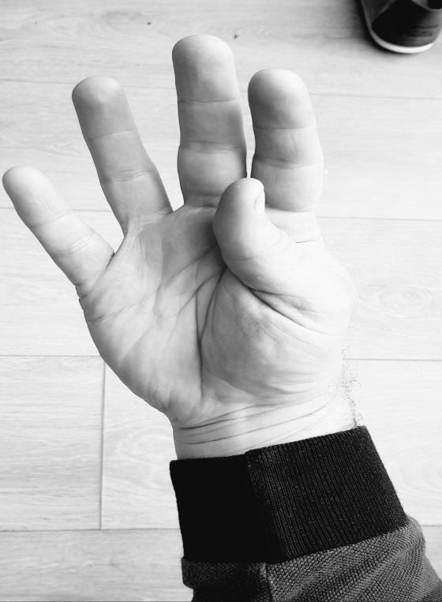
Sometimes we cannot control our emotions and we all have outbursts of emotion, this is okay, but we all need to learn our own triggers, our tolerance levels and also how to calm ourselves down. We all have strategies to do this and we all have things that we need and enjoy. Try to remember that things will settle down and you will feel calm again.
Our mid/lower brain is now free and our big emotions are now being displayed, this means that we may shout at people, hit out and say things that we do not mean.
Until the upper and lower brain are connected again, there will be no rational thought and it takes time for you to feel safe again and for the upper brain to hug the lower/mid brain again.
Our upper brain has become overwhelmed with information and is no longer protecting our mid/lower brain and they are no longer connected. This means that it no longer has any influence over our emotions.

A safe space
When we are stressed or anxious it is good to have a safe space to go to. This needs to be a place where you can think and relax and that will allow you to calm down. This could be your bedroom and you could hide under the covers or put some music on, it could be in your garden or your local park where you can just breathe and take in the oxygen you need to self-regulate. This means that you are able to calm yourself down.
When you are in your safe space you should focus on you and people need to know that this is your safe space and that you should not be disturbed, but remember to tell someone where you are, just so they can check on you from time to time.
When they do check in on you, make sure that you respond to them, you can tell them to leave you alone, but do it in a way that lets them know that you are okay, but you still need some space.

A trusted person
It is a really good idea to have someone that you can talk to if you are worried about anything, they cannot promise to keep everything to themselves, especially if you are in any danger, they have to make sure that they tell someone else who can help you. This is scary, but you must trust them that they are helping you.
Make sure that you remember that this person is someone that you trust and they are not going against you by telling someone else, but they only have to tell someone if you are in any danger or they are concerned for your physical or mental health.

Safeguarding support in school
We are always here for you if you need any help or support and we have a dedicated safeguarding team who are available throughout the school week, please contact the team using the details below.
Email: admin3213@we-learn.com (checked between 8am and 3 pm Monday to Friday)
Phone: 01788 542610

Safeguarding Team
Mrs Timson
Mrs Francis
Mrs Jones
Mrs Oakes

SEND Support

If you require this in a larger print or any adaptations then please contact Mrs Francis (SENDCO) on Francis.H@welearn365.com

