Instructions for Microsoft teams for live sessions with your teachers.
Download Microsoft teams
- On a laptop: google ‘Microsoft teams’ and click on the first link. Then, click ‘download teams’ at the top of the screen, then the purple ‘download teams’ button – then you shouldn’t have to do anything else
- On a phone: download ‘Microsoft teams’ app on Appstore
After it is downloaded you don’t need to make an account or anything just leave it
Being invited to a meeting
A member of staff will send you an email invite to a meeting on teams via your childs email address (with a time that you can accept or decline, and a link to join the meeting)
When you are ready to start the meeting
Click on the link in the email that should say something like: ‘Join Microsoft teams meeting’
Then click the option that says ‘Open in Microsoft teams’ (as you have already downloaded it)
You can then enter a name and join as a guest
Turn on your camera and turn off microphone until asked to unmute
It should then come up with a video screen (with you on it, if you have your video turned on) that says ‘waiting to be let into the room’
Whoever organised the meeting should let you in and you will be connected

Instructions for Oak National Academy Online Learning
Go to https://www.thenational.academy/
Click on lessons under pupils.
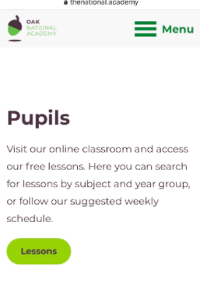
Click subjects at the top of the screen if on PC / laptop or bottom if on a phone / tablet.
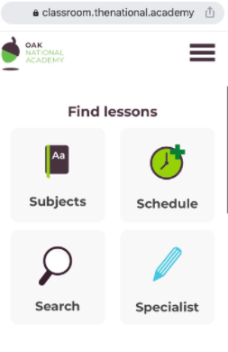
Then select the key stage your child is in.
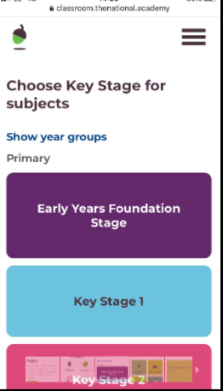
Then subject and select the lessons from your child’s home learning sheet.
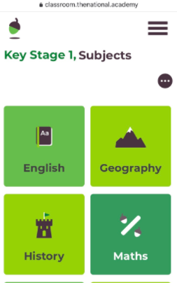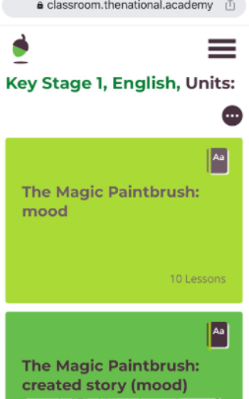

If you are self isolating and the class is in school, instructions for Oak National Academy online home learning.
Go to https://www.thenational.academy/
Click on lessons under pupils.
Click schedule at the top of the screen.
Follow the schedule for your year group.

Accessing welearn email
Go to http://www.welearn365.com
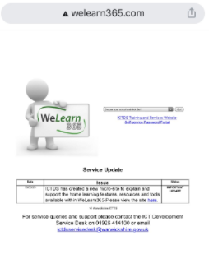
Click on St. Matthews Bloxam C of E Primary School
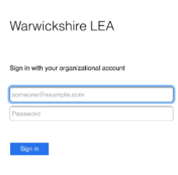
Type in your username and password (provided from school.)
This will take you to your child’s emails, click on my mail for emails and they can access all the links on the pages including Purple Mash (a great educational resource.)


