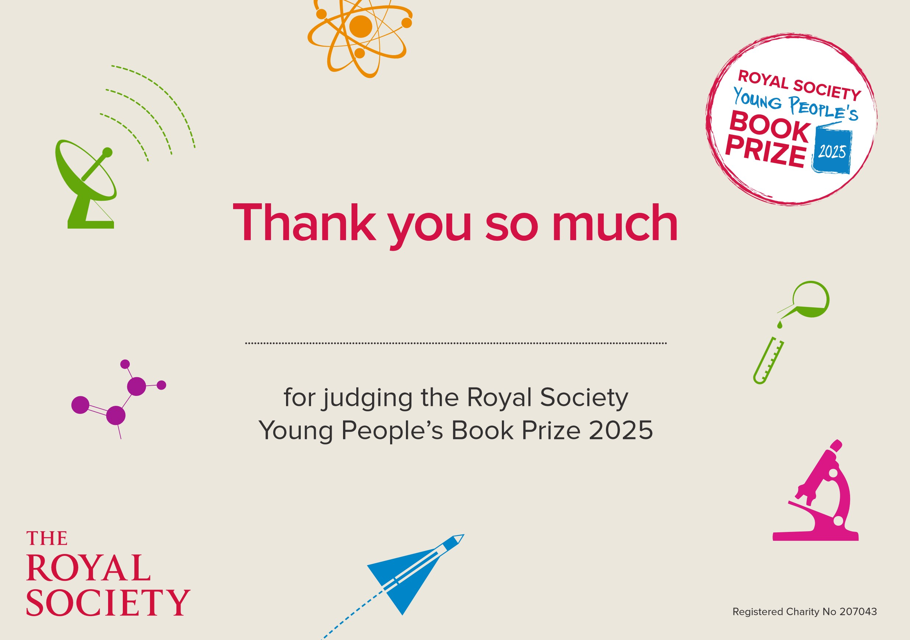
St Matthews Bloxam C of E Primary School

