 | 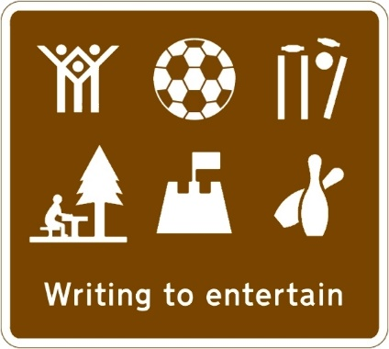 | 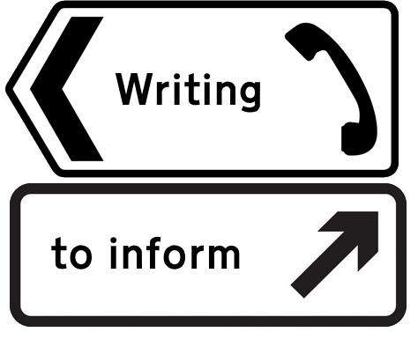 | 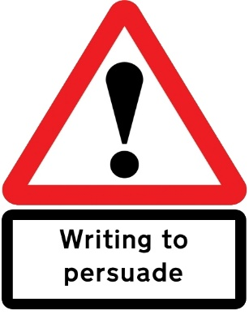 | 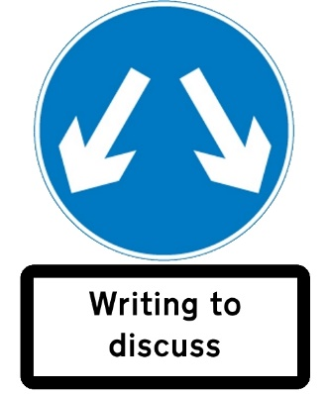
KS1 | Story  Description  Poetry | Recount  Letter  Instruction
LKS2 | Narrative  Description  Poetry | Explanation  Recount  Biography  Newspaper (year 4 only) | Advert  Letter  Poster  Debate
UKS2 | Narrative  Description  Poetry | Reports  Biography  Newspaper  Essay | Advertising  Speech  Campaign/Discussion  Debate | Argument  Newspaper  Review
St. Matthew’s Bloxam Writing Outcomes Long Term Plan 2022

Further guidance (inclusive of, not exclusive)

 | Poetry  All children should read, write, perform and appreciate free-verse poetry and familiar poems | Story/ narrative
KS1 | Rhyming couplets  List poems  Calligrams | Stories with predictable phrasing  Stories that reflect children’s own experience  Traditional tales  Fairy tales  Myths
LKS2 | Limericks  Haiku  Tanka  Kenning  Cinquain  Spoken word/rap | Traditional tales/ fables  Write and perform a playscript  Traditional tales/ fairy tales  Adventure stories  Myths/ quests  Story settings  Stories with a theme
UKS2 | Cinquain  Spoken word/rap  Monologues | Traditional tales- legends  Suspense and mystery  Fiction from our literary heritage  Fiction genres  Review key narrative techniques

