Maths apps to support your child at home
Maths apps are a great way of supporting our children with their knowledge of number. Using the apps regularly has a huge benefit to a child’s attainment levels in school.
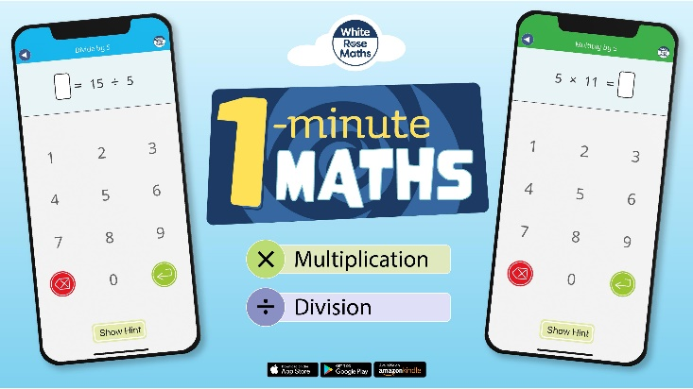
1-minute maths app from White Rose. This free app is particularly useful for children who need support with adding, subtracting, multiplying and dividing. It helps build fluency so children do not need to count on using their fingers. It is great for all primary age children as you can choose the difficulty level!
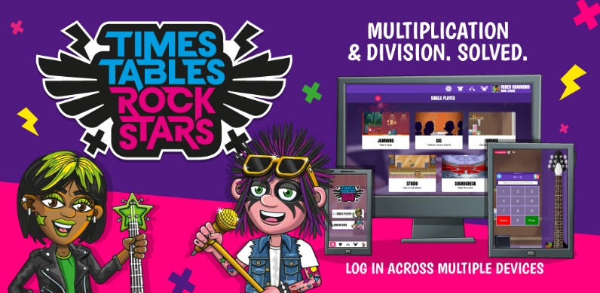
Times table Rock Stars will support children in learning their times tables. Children from Year 2 to Year 6 have an individual username and password for this. Regular practice will enable children to become fluent at their times tables, which will be a big support moving up through school.
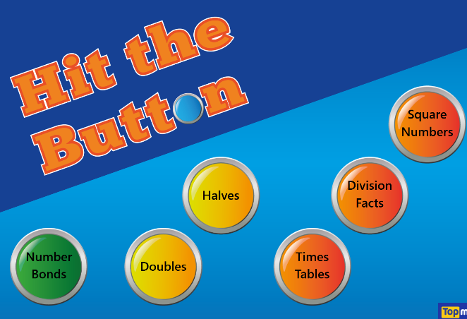
A free website, which allows children to answer questions linked to times tables, doubles, halves, number bonds and square numbers.


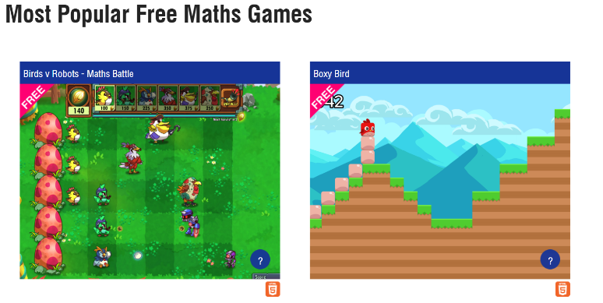
Mathsframe is a free website which has lots of interactive maths games on it. Children can choose which game they want to play and they include challenges which the children have to complete!

