How can I support my child at home with their times tables?

Practising your times tables and number bonds with your child isn't always easy. There are many different ways to learn them and below we have detailed a few tips and tricks to help you at home. Confidence with times tables is really important for children in primary school. By ensuring that your child is confident with times tables, you will be giving them some essential tools for success in mathematics.

1. Get your child familiar with multiplication concepts
The first step with multiplication is to make sure your child is familiar with what the numbers in multiplications really represent. Before they can cope with multiplication they need to be confident with sequences of numbers.

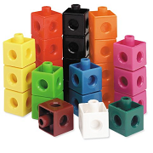You can start when your child is quite young by practising counting in twos and threes, making number patterns and solving simple mathematical problems. Counting objects, making sets of similar objects and using blocks or LEGO can all help to increase your child’s confidence with number bonds and multiplication facts.

2. Double your numbers
If your child learns how to double numbers this will help them to make connections between different times tables, for example the 2, 4, and 8 times tables.

3. Practise tables as a time-filler
When you’re sitting at traffic lights or waiting in the doctor’s surgery it is the perfect opportunity for a bit of times table practice! It’s always better (for both your child and you!) to just spend a few minutes reciting or testing times tables rather than going into overdrive and spending too long practising them.

4. Use the right vocabulary
Make sure you are using the right language to talk about multiplication.

Take a simple multiplication sum, such as 3 x 5 = 15. The 3 and the 5 are what we call factors of 15 and that 15 is a multiple of 3 and 5.

You can also demonstrate this by looking at the whole 3 times table written out in a list. Point out that each answer is a number that is a multiple of 3.

Finally, you can give your child a few sums to solve that use multiples of 3.

5. Help them with the ones they find tricky
There are usually one or two multiplication facts in each times table that are more difficult. When you notice that your child is stumbling over the same fact each time, try to give them extra practice. You could even get your child to write the fact out in a fun way on a piece of card and then stick it somewhere prominent (like on the fridge) so that they have an extra reminder!

6. Use a number grid
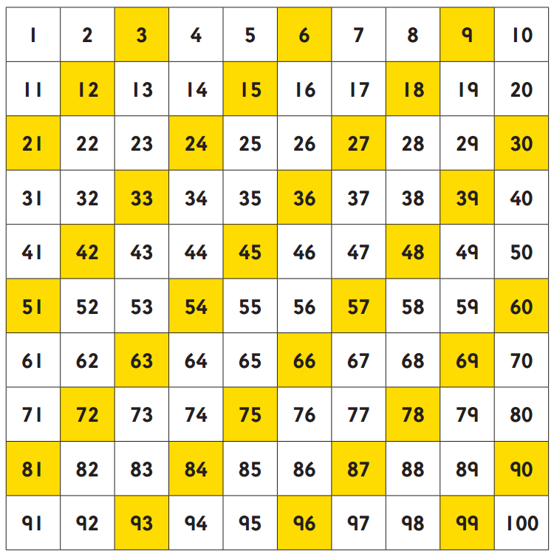
Printing off a simple 10 x 10 number grid can be a great way to demonstrate how times tables relate to number sequences. You can get your child to colour in multiples of different numbers on different number squares so that they can clearly see the number patterns.

7. Divide and conquer
As well as learning the times tables, your child should also know the division facts for each times table. (For example, if 3 times 5 is 15, 15 divided by 5 is 3, and 15 divided by 3 is 5.)

8. Make it real
The danger with too much rote learning of times tables is that children can fail to see the use of times tables in real life. Try to take opportunities to get your child to use multiplication in problem solving, for example working out quantities for scaling up a recipe, or calculating the price of more than one item of shopping.

9. Create a challenge
Make it fun by turning times table practice into a competition or challenge for your child, by timing them and keeping a record of their scores. You could even join in yourself and set a challenge to learn a more difficult times table, such as the 13 times table and get your child to test you at the end of the week in exchange for testing them.

Please check out some of the activities attached to the page (at the bottom) to try at home. Below is also a few links to games for children to play and learn.

10. Use websites and games to support understanding

Online games are a great way of engaging children and making times tables fun! All children at St Matthew’s Bloxam have their own personal username and log in to Times Tables Rock Stars. Below are other useful websites the children can use.

https://ttrockstars.com/

https://www.timestables.co.uk/

https://www.topmarks.co.uk/maths-games/daily10

https://www.topmarks.co.uk/maths-games/7-11-years/times-tables

https://www.oxfordowl.co.uk/for-home/maths/help-with-times-tables/

https://www.mathsisfun.com/timestable.html

https://www.topmarks.co.uk/maths-games/hit-the-button

https://mathsframe.co.uk/

