30th September to 4th October
Welcome to our home school communication! Each week you will get an overview of the class learning and will be set some home tasks too. The children will have spellings, which will be tested on a Friday, times tables practise and reading. Home school communication books should be returned to school on a Wednesday.
Please find below the summary of our week in school.
English | This week, we started to see how speech is punctuated and could spot errors in speech punctuation. Year 3 also worked hard to learn and perform a poem – thinking about their tone of voice and actions they could include to bring the poem to life.
Maths | Year 3 we continued to look at exchanging numbers across 10s and 100s when adding and subtracting. We have been doing this by looking at base tens and counters and place value grids.
Science | Over the last two lessons, Year 3 have found out about Mary Anning and how she was one of the first fossil hunters. They created their own fact files with information about her they have learnt.
Homework tasks
Project –
- Identify different rocks around your local area and think about their uses.
- Draw and label a character in the style of Quentin Blake.
- Write a letter to George from George’s Marvellous Medicine to warn him of what might happen if he feeds the potion to Grandma.
- Create a poster showing numbers in Spanish.

These project ideas are for the whole of the half term and are suggestions for extra work
Reminders/Notices
- P.E. is on a Monday and Tuesday
- Do your best with the spellings. If you find them difficult, then just focus on a few of them – this is absolutely fine. If you aren’t sure what a word means, use a dictionary at home or school to help
Maths – remember the ones column will stay the same. Draw a place value grid and counters to help.
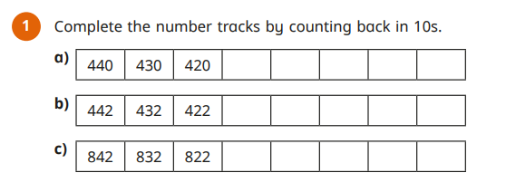
And… Keep reading every day! Please make a note of when you have read below. |  | Multiplication / Maths  Use TTRS!  Please have a go at the sheet in your book. If you would like to have a go at some more then please do. The website below formulates sheets quickly and is free to use.  http://www.timestables.me.uk/
  Date | Book | Pages read/comments
If you would like to email anything to us, please use admin3213@welearn365.com and put it to the attention of Year 3. We appreciate your continued support from home.

