13th – 17th October 2025
Welcome back to the new school year! Each week you will get an overview of the class learning and will be set some home tasks too. The children will have spellings, which will be tested on a Friday, times tables practise and reading. Home school communication books should be returned to school on a Wednesday.
Please go to our class page on the school website - https://www.st-matthewsbloxam.co.uk/

Please find below the summary of our week in school.
English | In English this week, we have been developing our dialogue and exploring emotions that change throughout the sequence of a narrative, in preparation for writing our own narratives from the point of view of another character.
Maths | This week in maths, we have been revisiting our knowledge of written addition and subtraction. We have practised applying this knowledge to multi-step word problems.
Science | This half term our science unit will be forces. This week, we have looked at friction and how different surfaces create more or less friction through experimentation.
Homework tasks
Project – Our theme this half term is ‘The story of the Trojan Horse: historical fact, legend or myth?’ At home, research the allegedly lost city of Atlantis. What can you tell me about this, come to a conclusion whether you think this is historical fact, legend or myth. Give evidence for your opinion. Note- this could be research presented in any way you wish! Whether it is a powerpoint, a piece of writing, a model made either physically or on a game like Minecraft! (To be completed over the half term).

Maths/Grammar-
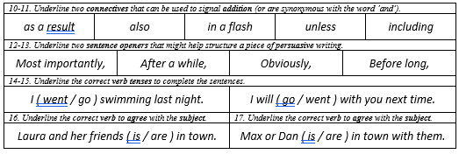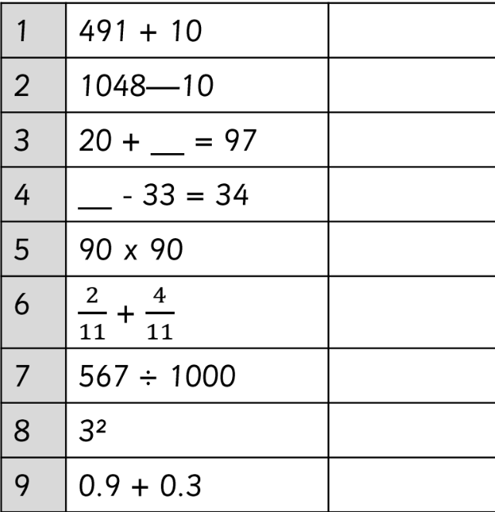
  And… Keep reading every day!  Read 1: _____________  Read 2: _____________  Read 3: _____________ |  | Multiplication  There is a times tables rock stars battle online. How many points can you score?  There will be prizes for top competitors

If you would like to email anything to us, please use admin3213@welearn365.com and put it to the attention of Miss Blackaby
Please remember: PE is on Thursday this half term so please wear PE kit on these days. We will be starting swimming lessons on Monday so please bring swimming kit and a towel for this. Please ensure you have trainers in school as we may be outdoors on other days of the week.
We appreciate your continued support from home.

