23rd – 27th February 2026
Welcome to our home school communication! Each week you will get an overview of the class learning and will be set some home tasks too. The children will have spellings, which will be tested on a Friday, times tables practise and reading. Home school communication books should be returned to school on a Wednesday.

Please find below the summary of our week in school.
English | We have continued to read “Everest” and we wrote brilliant diary entries on how we would feel on our journey and when we reached the summit of Mount Everest. We started to debate whether or not people should climb mountains and we enjoyed the class debate.
Maths | We have continued with ways to multiply using the column and area model to multiply 2 and 3 digit numbers.
Geography | We have investigated what the “Treasures of untold value” Thomas Barclay wrote about in 1898 and how water was this vital resource when they found the link to Chloera. We also used coordinates and read maps.
PE | We continued Drumba on Tuesday and started cricket on Thursday.
Talking task –
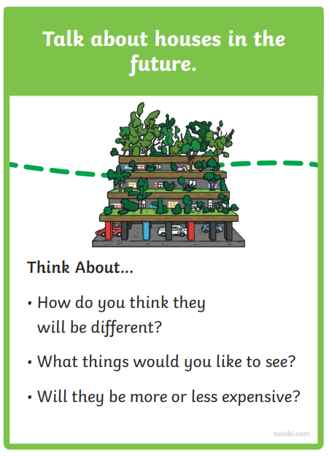
Homework – spelling sheet and multiplication questions.
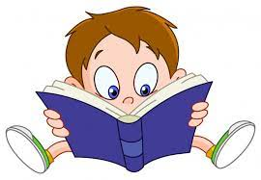Remember, to keep reading every day!  Read 1: .  Read 2: .  Read 3: . |  | 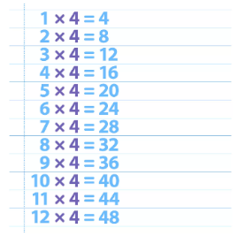  Multiplication – Keep practising your multiplication and go on Times Tables Rock Stars.
Remember – PE will continue to be on a Tuesday and Thursday and please have trainers in school for other days.
Please visit our class page on the school website - https://www.st-matthewsbloxam.co.uk/ .
If you would like to email anything to us, please use admin3213@welearn365.com and put it to the attention of Miss Blackaby.

We appreciate your continued support from home. Miss Blackaby and Miss Deiko

