Year 5 2025 – 2026
We are looking forward to teaching you in September.
Class Teacher: Learning Support Assistant:
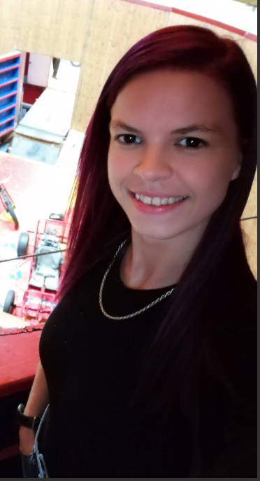
Miss Blackaby Miss Deiko

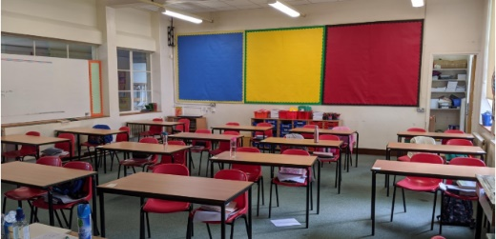
This is the Year 5 classroom,

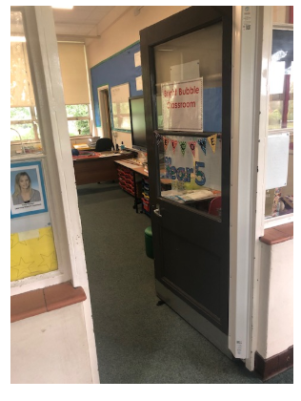

This is the Year 5 classroom door.

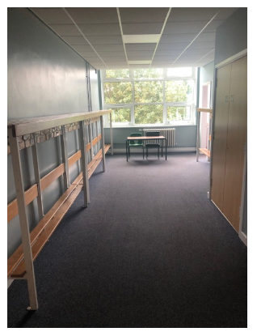

This is the cloakroom, where you hang your coat and bag on your peg.

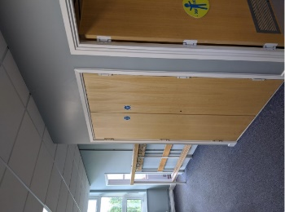

These are the Year 5 Toilets

